21st Century Lesson Cycle Template
Grade: 4 Subject: Math
Unit: Measurement: Time Analog vs Digital
Learning Target: Practise telling time on a 12 hour digital clock using the proper vocabulary.
Curriculum Outcomes:
M01.04 Express the time orally and numerically from a 12-hour digital clock.

Screencast Support: Analog vs Digital

Resources/AT Tips: Digital to analog clock, Digital Clock on Pearson Interactive tools available on NSVS Math 4-6 commons,

Lesson Procedure |  | 21st Century Skills
I do:  - Activate prior knowledge by asking where can you find out what time it is? Students will describe analog clock and the various devices they have that tell the time. What is the difference between a.m. and p.m., what is something you might do during each.  - Discuss that in today’s society that we see time in a variety of places. A clock with numbers and no hands is a digital clock. It shows the time using numbers and a colon.  - Using digital clock found on Pearson Interactive tools, put the digital clock on the smartboard. Practice telling time as a class using all the vocabulary we have learned up to this point. Students should tell the time in two different ways. |  | Find, validate  remember, understand  collaborate, communicate  analyze, synthesize  critical thinking  evaluate, leverage  create, publish  citizenship
We do:
- As a class play Analog Digital Time, use Team Shake app to choose students randomly to play.
- Students create their on clock cards combining analogue clocks with digital time cards. Trade with tablemate and try to match the digital clock with the analogue clock.

You do:
- Watchin Doing? Sheet – Students will look at digital time in the a.m. and p.m. and choose appropriate activities that they may be doing at that time.
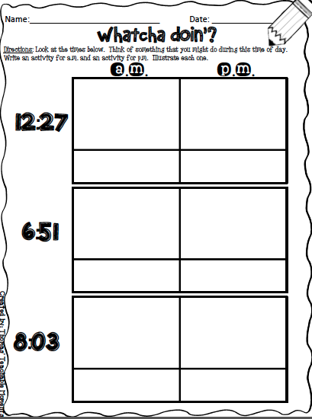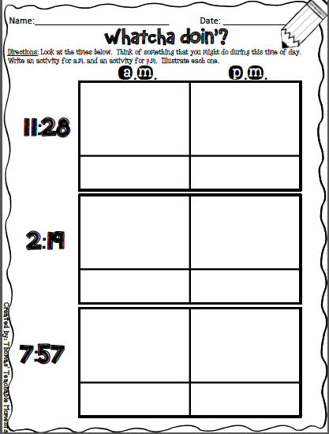

We share:
At the end of the math period bring the class together and review the Watchya Doin’? sheet. What are some activities that you are doing in a.m. and the p.m.

Differentiation
Adaptations:  Have struggling students watch the screencast Telling Time Analogue vs. Digital  Give one on one attention to struggling students. Have them us manipulative clock and practice making time to the hour and describing that time.  Students may access clock for kids app on their iPad to support telling time. | Enrichment:  Students that have a strong grasp of this can move onto the next in the series and begin by watching the screencast on Elapsed Time
Evaluation:
On going evaluation, taking note of students that are struggling and those that can apply digital time to an analog clock.

Blank Analog Clocks
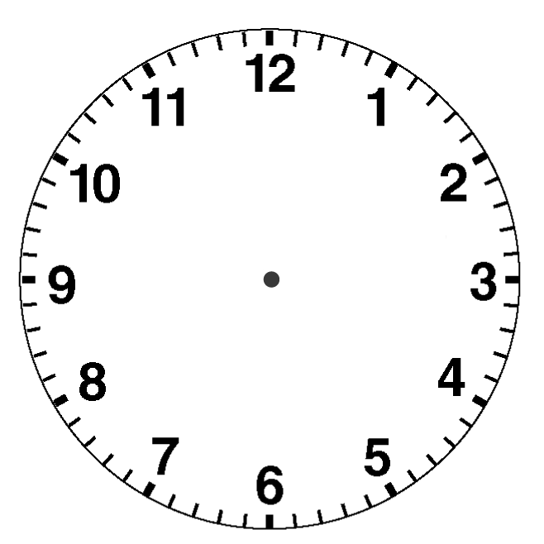

Blank Digital Clocks
