|  |  |  |
| --- | --- | --- |
| **Math 4** | | |
| **Subject: Math**  **Unit: Exploring Hundredths** | | |
| **Learning Target:** Students will relate decimals to fractions and fractions to decimals (to hundredths). They learn that one hundredth is one equal part of 1 whole divided into 100 equal parts. | | |
| **Curriculum Outcomes:**  **N10.01**Express orally and symbolically, a given fraction with a denominator of 10 or 100 as a decimal.  **N10.02** Read decimals as fractions.  **N10.03** Express orally and symbolically a given decimal in fraction form.  **N10.04** Express a given pictorial or concrete representation as a fraction or decimal (15 shaded squares is 0.15 or 15/100.) | | |
| **Screencast Support:**  [Exploring Hundredths](https://www.youtube.com/watch?v=yWcNQkmpYVk) <https://www.youtube.com/watch?v=yWcNQkmpYVk>  [Understanding Hundredths](https://www.youtube.com/watch?v=HfjLdzBjFkU) <https://www.youtube.com/watch?v=HfjLdzBjFkU>  (an additional screencast looking at decimals) | | |
| **Resources/AT Tips:**  **-Screencast** – **Exploring Hundredths**  -iPads  **-** [Online fraction / decimal games](http://www.sheppardsoftware.com/math.htm#decimals) <http://www.sheppardsoftware.com/math.htm#decimals>  -Hundredths grid paper / interactive grid paper  -Decimal **Fraction circle** activity  **-** Flats and Rods as needed  -**Assessment Activity** sheet | | |
| **Lesson Procedure** | | **21st Century Skills** |
| **I do:**  **Activate Prior Knowledge**   * Present a 100th chart on **Smartboard**. Manipulate concrete materials. **Generate a discussion**:   -Ask, ‘What fraction is represented by 3 squares on the hundredths grid? (3 hundredths)  -Ask, ‘Which blocks would you use to model 10/100?’  -Ask, ‘ How else could you model 10/100?’ (use 1 rod)  -Ask, How could you model 75/100?’ (use 75 rods or 7 rods and 5 units).  -Ask, ‘How can you draw it?’ (100th grid) | | find, validate  remember, understand  communicate |
| **You do:**   * Together, read from Math Sense 4, page 201, how to record hundredths. * Present the Screencast - [Exploring Hundredths](https://www.youtube.com/watch?v=yWcNQkmpYVk) https://www.youtube.com/watch?v=yWcNQkmpYVk * **Discuss** screencast. | | collaborate, communicate  analyze, synthesize |
| **We do:**   * Ask students to work on page 201, questions 1 and 2, 4 and 5. They may **collaborate**. * Working in pairs, using iPads, further reinforce hundredths and decimals by having them explore the **online game**- **fractions and decimals.** * Have students investigate the **fraction circle activity** below. | | collaborate, communicate  analyze, synthesize  critical thinking  evaluate, leverage |
| **We share:**   * **Together correct** activity sheet. * **Discuss** the helpfulness of the online game and screencast. | | collaborate, communicate  critical thinking  evaluate, leverage  create, publish  citizenship |
| **Differentiation** | | |
| **Adaptations:**   * Have students’ practice counting flats by ones and rods by tenths, until they grasp the concept. * **Review the screencast**, Exploring Hundredths as often as needed. | **Enrichment:**   * Students could research to find out when hundredths is used in the ‘real world’. * Have students start to explore money. | |
| **Assessment:**  -Ask students to complete the attached **assessment sheet**.  **-**As students play **‘matching fractions’** – reviewing tenths, record observations as you rotate around the room, observing the students as they match fractions to manipulatives. | | |
| **Teacher Reflection:**  Pay attention to make sure studentsunderstand thatten-hundredths is the same as one tenth. (10/100 or 0.10 is the same as 1/10. ) This can be difficult for students to grasp; they will need addition time and practice here. | | |

Hundredths Grids

|  |  |  |  |  |  |  |  |  |  |
| --- | --- | --- | --- | --- | --- | --- | --- | --- | --- |
|  |  |  |  |  |  |  |  |  |  |
|  |  |  |  |  |  |  |  |  |  |
|  |  |  |  |  |  |  |  |  |  |
|  |  |  |  |  |  |  |  |  |  |
|  |  |  |  |  |  |  |  |  |  |
|  |  |  |  |  |  |  |  |  |  |
|  |  |  |  |  |  |  |  |  |  |
|  |  |  |  |  |  |  |  |  |  |
|  |  |  |  |  |  |  |  |  |  |
|  |  |  |  |  |  |  |  |  |  |

|  |  |  |  |  |  |  |  |  |  |
| --- | --- | --- | --- | --- | --- | --- | --- | --- | --- |
|  |  |  |  |  |  |  |  |  |  |
|  |  |  |  |  |  |  |  |  |  |
|  |  |  |  |  |  |  |  |  |  |
|  |  |  |  |  |  |  |  |  |  |
|  |  |  |  |  |  |  |  |  |  |
|  |  |  |  |  |  |  |  |  |  |
|  |  |  |  |  |  |  |  |  |  |
|  |  |  |  |  |  |  |  |  |  |
|  |  |  |  |  |  |  |  |  |  |
|  |  |  |  |  |  |  |  |  |  |

|  |  |  |  |  |  |  |  |  |  |
| --- | --- | --- | --- | --- | --- | --- | --- | --- | --- |
|  |  |  |  |  |  |  |  |  |  |
|  |  |  |  |  |  |  |  |  |  |
|  |  |  |  |  |  |  |  |  |  |
|  |  |  |  |  |  |  |  |  |  |
|  |  |  |  |  |  |  |  |  |  |
|  |  |  |  |  |  |  |  |  |  |
|  |  |  |  |  |  |  |  |  |  |
|  |  |  |  |  |  |  |  |  |  |
|  |  |  |  |  |  |  |  |  |  |
|  |  |  |  |  |  |  |  |  |  |

|  |  |  |  |  |  |  |  |  |  |
| --- | --- | --- | --- | --- | --- | --- | --- | --- | --- |
|  |  |  |  |  |  |  |  |  |  |
|  |  |  |  |  |  |  |  |  |  |
|  |  |  |  |  |  |  |  |  |  |
|  |  |  |  |  |  |  |  |  |  |
|  |  |  |  |  |  |  |  |  |  |
|  |  |  |  |  |  |  |  |  |  |
|  |  |  |  |  |  |  |  |  |  |
|  |  |  |  |  |  |  |  |  |  |
|  |  |  |  |  |  |  |  |  |  |
|  |  |  |  |  |  |  |  |  |  |

Assessment Activities

|  |
| --- |
| **Exploring Hundredths**  5-36-35-36-25-36-11. Write a fraction and a decimal for the shaded part of each grid. a) b) c)    2. Write each number as a decimal.  a)  b)  c)  d)  3. Write each decimal as a fraction.  a) 0.04 b) 0.14 c) 0.07 d) 0.72 |

Master 1.20

|  |
| --- |
| **Equivalent Decimals**  1. Colour a hundredths grid to show each decimal. Write an equivalent decimal.  a) 0.6 b) 0.40 c) 0.1 |

Decimal Fraction Circles

Work alone or with a partner.  
You will need glue, heavy paper, and scissors.

* Glue the circles below to heavy paper.
* Cut out each circle.
* Cut along the dotted line to make a slit halfway into each circle.
* Slip the circles together at their slits.  
  Put the blank circle on top of the circle marked in hundredths.  
  You should be able to turn the top circle over the bottom circle.
* Use the circles to show each fraction: , , , , 
* Record each fraction as a decimal.

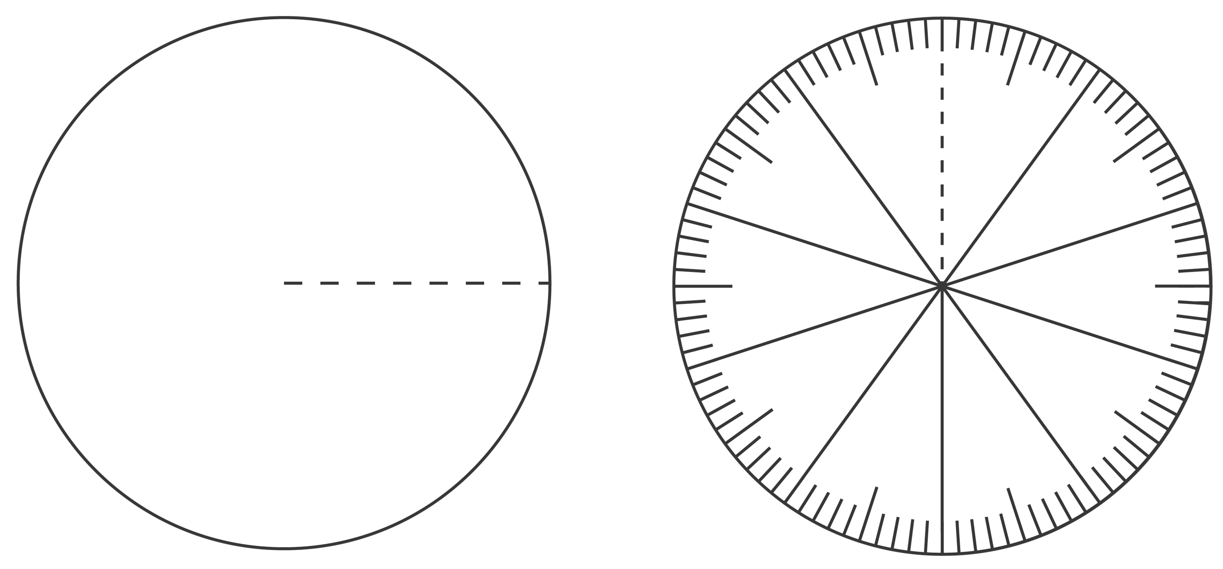

**Take It Further:** Try to show the fraction .

**Matching Fractions**

You can use paper and pencil or your iPads when drawing and recording your responses.

Work with a partner.  
You will need 15 cards with fractions written on them, a geoboard,   
geobands, Pattern Blocks, square dot paper, and triangular dot paper.

* Place the cards face down.
* One student chooses a card and reads the fraction.
* Work together to model the fraction using a geoboard and  
  geobands, or Pattern Blocks.
* Draw a picture of your model on paper.  
  If you used a geoboard to model the fraction,   
   draw it on square dot paper.  
   If you used Pattern Blocks to model the fraction,   
   draw it on triangular dot paper.

**Take It Further:** Write fractions with tenths, such as  
, , and  on cards.  
Put these cards in your pile.  
Repeat the activity.