Math 4
Subject: Math
Unit: Adding Decimals to Tenths

Learning Target: Students learn that decimals can be estimated and added using base ten blocks and place value. When adding decimals vertically, the decimal points are always aligned.

Curriculum Outcomes:
N11.01 Predict sums of decimals using estimation strategies.
N11.02 Solve problems that involve the addition of decimals to hundredths.

Screencast Support:
Estimating and Adding Hundredths

Game: Adding tenths and Hundredths

Resources/AT Tips:
- iPads Number Basics app 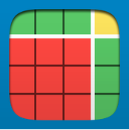
- Math Makes Sense 4 text
-Decimal place value mats
- Flats and rods
-100th grids
- Pearson interactive base ten blocks – use to demonstrate (nsvs site)
-Game ‘Adding Tenths and Hundredths’ – screencast demo

Lesson Procedure |  | 21st Century Skills
I do:  Activate Prior Knowledge  - Review the value of base ten blocks when modeling decimals.  (flat= 1whole , rod= 1 tenth). Demonstrate using concrete base ten blocks.  - Review how to estimate numbers to the nearest whole.  1.6 – is it closer to 1 or 2?  1.2 – is it closer to 1 or 2? |  | find, validate  remember, understand  communicate
You do:  - Together look at estimation strategies on page 206. Then, explore the three strategies for adding decimal: use base ten blocks, add left to right, and use a number line.  - Demonstrate how to add decimals using Pearson interactive base ten blocks. (Use base ten blocks and a decimal place value mat- demonstrate how to model adding decimals, like 3.6 + 1.1 and 1.3 + 3.5, etc.) (nsvs site) (see below)  - Present the screencast, Estimating and Adding Hundredths.  - Discuss screencast. Review regrouping using the SmartBoard or Pearson tools. |  | collaborate, communicate  analyze, synthesize
We do:  - Collaboratively, have students complete the activity sheet below, Estimating and Adding Decimals. They build and add decimals using the app, Number Pieces or they use the concrete base ten blocks.  - Play the game as seen on the screencast. Choose decimals for them to add or have them choose their own numbers to add. |  | collaborate, communicate  analyze, synthesize  critical thinking  evaluate, leverage
We share:  - Together correct text and activity sheet; have some students use the SmartBoard to model the addition of decimals. Continue reviewing. |  | collaborate, communicate  critical thinking  evaluate, leverage  create, publish  citizenship
Differentiation
Adaptations:  - Provide a decimal place value mat as they add decimals.  - Have them continue to work with base ten blocks, representing decimals, independently and with partners. Use concrete blocks or the Number Pieces app. | Enrichment:  - Present some word problems that contain the addition of decimals. Then ask students to create their own addition story problems.
Assessment:
-Gather the completed assessment sheet.
- Record observations as you rotate around the room; noting how the students are doing. Assist as required.

Teacher Reflection:
Pay attention to make sure students are not adding the tens with tenths incorrectly.
– Ex: 0.9 +0.4=0.13. Review that 0.13 is 13 hundredths, or 1 tenth and 3 hundredths.
Practice adding decimals.

Name Date

Use the Number Pieces app or Base Ten Blocks to Estimate and then Add.

Adding Decimals to Tenths
1. Estimate each sum.
a) 3.1 + 4.2 b) 1.4 + 0.9 c) 6.2 + 8.1 d) 3.4 + 6.6

2. Add. Use Base Ten Blocks to help you.
a) 6.1 + 4.3 b) 1.4 + 5.3 c) 5.8 + 2.3
d) 1.8 + 0.9 e) 2.2 + 9.4 f) 4.8 + 4.8
Master 1.20

Pearson Tools can be used to demonstrate regrouping.

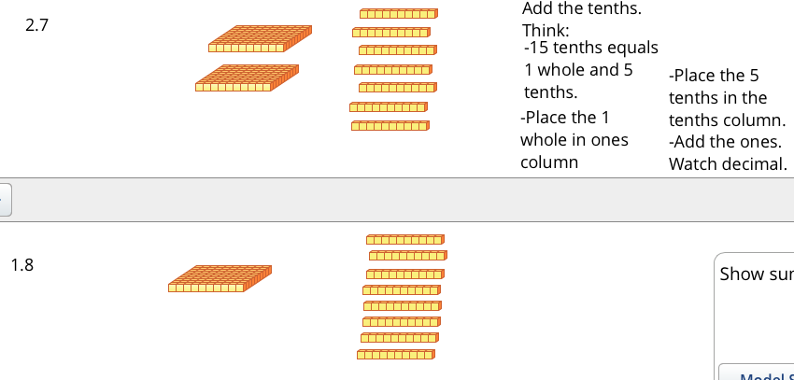

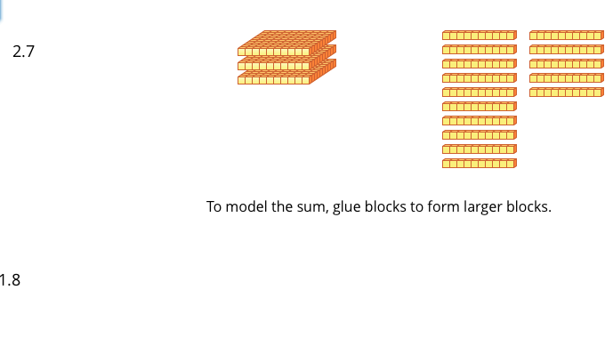

Hundredths Grids

