Grade 4
Grade: 4 Subject: Math
Unit: Measurement: Time quarter to
Learning Target: Telling Time – Quarter after

Curriculum Outcomes: M01.02 Express the time orally and numerically from a 12-hour analog clock
Screencast support: Telling Time quarter to
Resources/AT Tips:
screencast,
Analog Clock interactive whiteboard clock,
Exploring Time assessment.
Clock for kids app 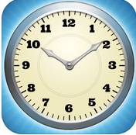 ,
iPads

Lesson Procedure |  | 21st Century Skills
I do:  These lessons depend on scaffolding. Understanding time to the hour, time to the half hour, time quarter after before understanding time quarter to is important.  Activate prior knowledge and review last lesson. – 60 seconds in a minute, 60 minutes in an hour.  Access interactive whiteboard clock. Point to the hour hand and the minute hand, practice telling time to the hour and to the half hour and quarter to with a few examples.  Remind the students of the how the clock can be divided into quarters. Using the interactive whiteboard clock draw the quarters on the clock. Each quarter is 15 minutes. It takes 15 minutes for the minute hand to travel from the 12 to the 3, 3 to the 6, 6 to the 9, and 9 to the 12. Each quarter is 15 minutes. When the minute hand is on the 9 there is only one quarter left until the next hour, we say it is quarter to the next hour. Give an example 2:45 (show it on the clock), in 15 more minutes it will be 3 o’clock, we say it is quarter to 3 we write it as 2:45.  Take note of the hour hand, it is close to the next hour but not there yet. Give more examples and allow time for practice.  Show screencast |  | find, validate  remember, understand  collaborate, communicate  analyze, synthesize  critical thinking  evaluate, leverage  create, publish  citizenship
We do:
Do a variety of examples. Using the team shake app have students come up and set the time. Pay close attention to the minute hand and the hour hand. Students tell the time using the vocabulary quarter after. When students tell the time write it, as it would be seen on the board, i.e. 8:45 and emphasize placement of the hour hand just past the hour, it is no longer exactly on the hour but closer to the next hour. They will need a lot of practice telling the time and using the vocabulary.

You do:
With your tablemate continue to practice telling time to the hour. One student will put a time to the hour on the iPad and the other student will tell the time to the hour. As you circulate watching, listening and helping listen for the specific vocabulary of quarter to. Students should be telling the time in two different ways, two forty-five and quarter to three.

Have students switch the game and practice telling time in the 4 different ways we have learned so far, o’clock, half past, quarter to and quarter after.

Students are to complete the Exploring Time assessment and pass it in.

We share:
Come back together as a group. Show 5 different times one at a time on the interactive whiteboard. Give students 5 seconds and then have the whole class answer at the same time.

Differentiation
Adaptations:  Have struggling students watch the screencast Telling Time: quarter to again.  Give one on one attention to struggling students. Have them us manipulative clock and practice making time to the hour and describing that time. | Enrichment:  Students that have a strong grasp of this can move onto the next lesson in the series by watching the screencast on Telling Time: to the minute
Evaluation:

Exploring Time assessment - you should already have a good idea of who is struggling with the concept, this will serve as more evidence of who needs more support.

Notes

Name:

Exploring Time
1. Write each time two ways.
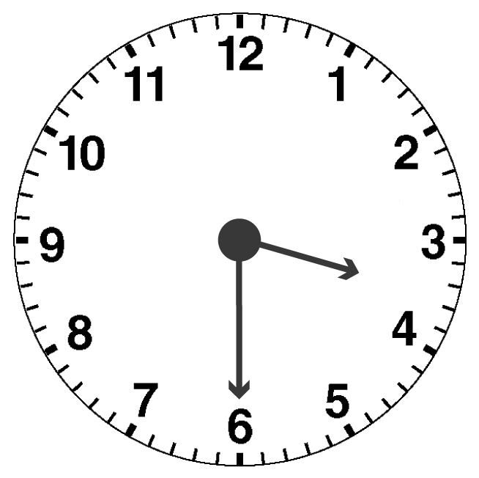
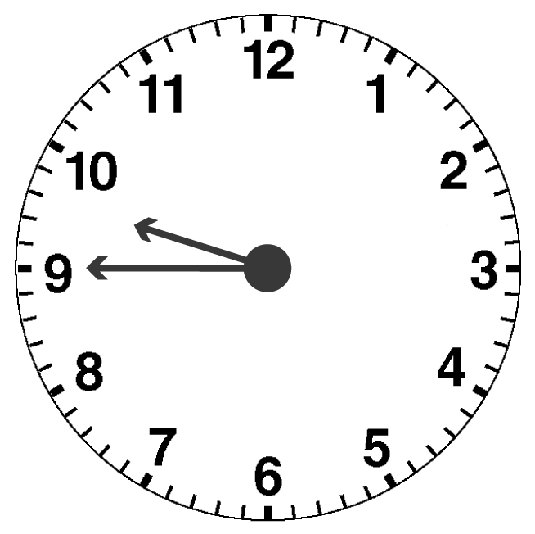
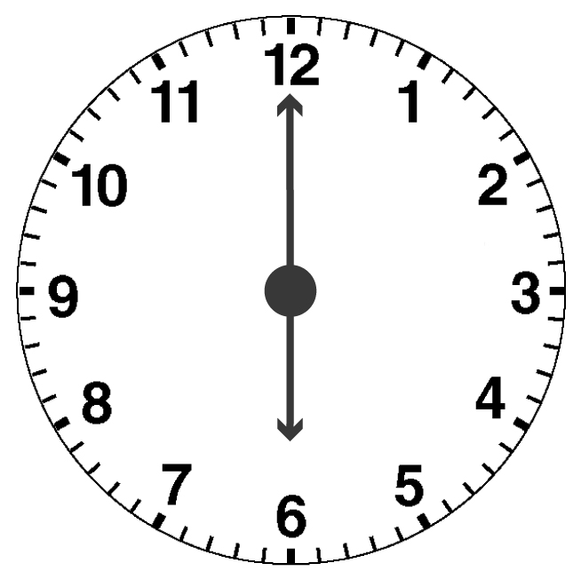
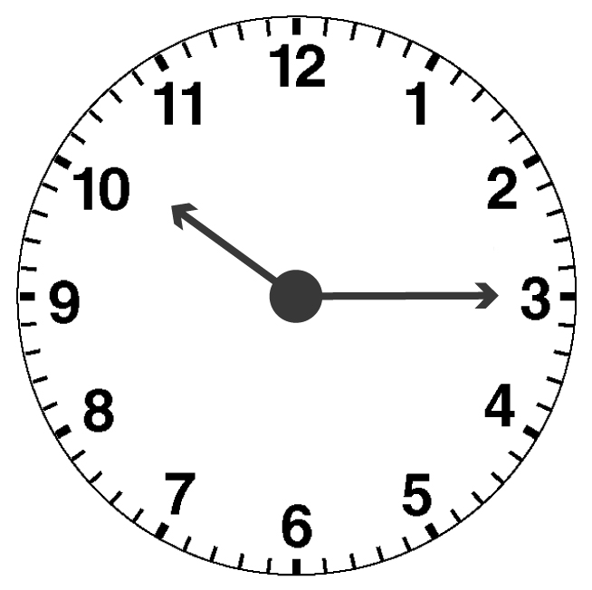
a) b) c) d)

2. Draw a digital clock to show each time.
a) half past 7 b) quarter after three c) ten o’clock

d) quarter to 2 e) six forty-five f) twelve thirty

