Measurement Assessment: Time
Use the Three Read Strategy when answering your questions.
1. Write each time using a 24-hour clock.

a) 4:45 p.m. _______________ b) 6:22 a.m. _______________

2. Write each time using a.m. or p.m.
a) 07:21 _______________ b) 23:50 _______________

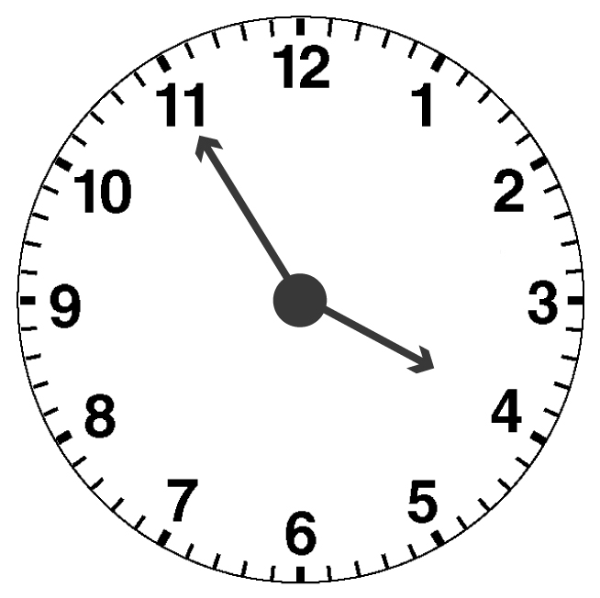
3. a) Write the time this clock shows.
_____________________

b) What time will it be in 35 minutes?
____________________

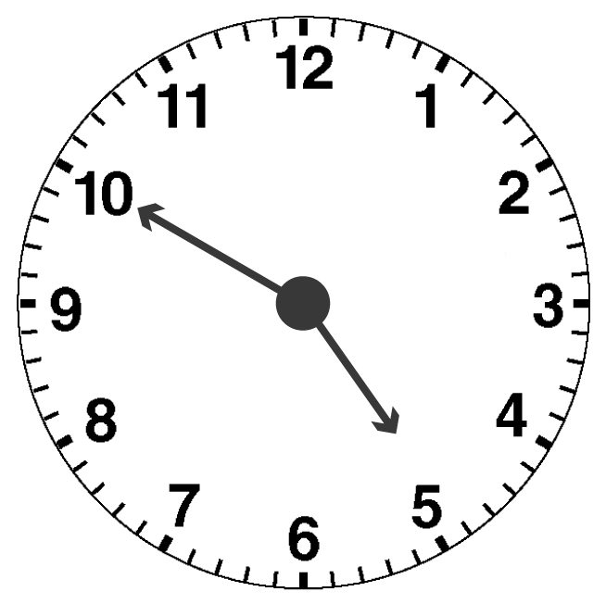
4. Leigh ran for 2 min, walked for 5 min, ran for 3 min, and walked for 5 min more. Then she stopped.
When she left home, the clock looked like this:
a) What time does the clock show?
__________________________

b) At what time did Leigh stop?
Show your thinking.
________________________

5. Al started his homework at 7:15 p.m. and finished at 7:50 p.m.
Natalie started her homework at 6:50 p.m. and finished at 7:10 p.m.

a) Whose homework took longer to complete? How do you know?
__________________________________________________
__________________________________________________

b) How much longer did it take one person to finish than the other?
Show your work.
__________________________________________________
__________________________________________________

6. What time might it be if the minute hand and the hour hand are opposite each other on a regular analog clock?

_____________________________________________

7. Write each date using metric notation.

a) October 31st, 2007 ____________

b) March 7th, 1999 ____________

c) Christmas this year ____________

