Grade 4
Grade: 4 Subject: Math
Unit: Number: Division
Learning Target: Use arrays to solve division problems with concrete materials

Curriculum Outcomes:

SCO N07 Students will be expected to demonstrate an understanding of division (one-digit divisor and up to two-digit dividend) to solve problems by
- using personal strategies for dividing, with and without concrete materials
- estimating quotients
- relating division to multiplication
N07.01 Model the division of two given numbers without a remainder, limited to a one-digit divisor and up to a two-digit dividend, using concrete or visual representations, and record the process pictorially and symbolically.

Screencast support:
Division using arrays
Resources/AT Tips:
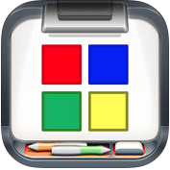 Color Tiles app
Explain Everything

Color Tiles – NSVS Pearson interactive tools

Showbie

Lesson Procedure |  | 21st Century Skills
I do:  - Activate prior knowledge: Fair Share – Using the color tiles app or color tiles found on NSVS Pearson Interactive tools, project 35 tiles on the board. Present the scenario of 7 friends sharing the tiles equally. Have a student come up show fair shares. What is this operation called? Division.  - Now take the same 35 tiles and arrange them in array. Students should be familiar with multiplication arrays and corresponding sentences. Have a student describe the multiplication sentence that would math the array, and the turn around fact.  - Write the division fact on the board.  - Show the screencast – Division using arrays |  | find, validate  remember, understand  collaborate, communicate  analyze, synthesize  critical thinking  evaluate, leverage  create, publish  citizenship
We do:  - Share a few more examples. Using the same pattern no remainders. Have the students follow along using the color tiles app and do it with you.  - Give the students the number 24. Have them share them equally, recording the multiplication sentence, the array and the corresponding division sentence.  - Ask the students if there is more than one way to divide 24 equally? Give 5-10 mins and share at the end. Have them create a screencast showing all the ways they can divide 24, the arrays, multiplication sentences and division questions. |  | Notes
You do:
- When the screencast is complete students work on the extra practice sheet and pass in via showbie.
We share: Have a few students share there explain everything with the class. Take the time to look at some of the numbers we know would have more than one division answer. Look for patterns on the hundred chart.

Differentiation
Adaptations:  Struggling students should watch the screencast again. Start with dividing by 2 and 3. | Enrichment:  Have students begin to experiment with numbers that do not divide equally.
Assessment:
Students should be continuously assessed as we work through this unit. Students that are experiencing difficulty may need one on one time with concrete manipulatives while others move on.

Notes:

Using Arrays to Divide
1. Write a division sentence for each array.
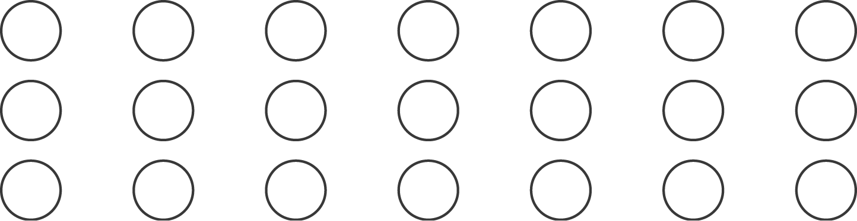
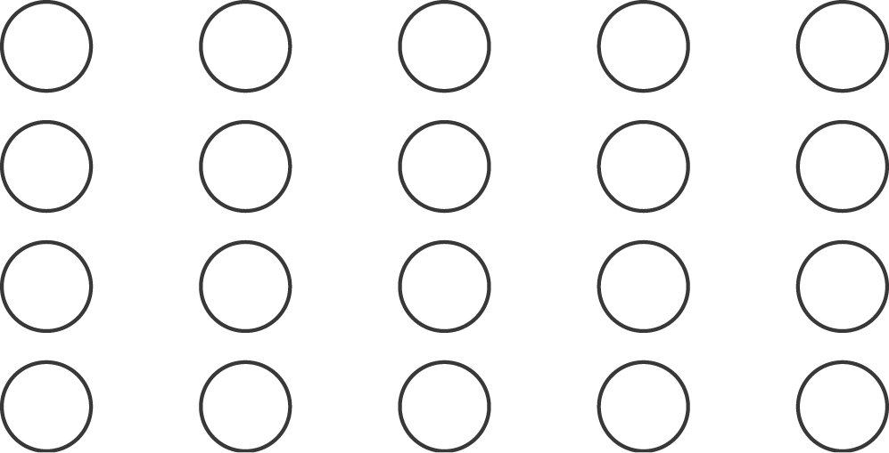
a) b)

2. Complete each division sentence.
a) 9 ÷ 1 = b) 24 ÷ 8 =

c) 30 ÷ 6 = d) 18 ÷ 6 =

3. A classroom has 32 desks arranged in 8 equal rows.
How many desks are in each row?

