Math 4
Subject: Math
Unit: Exploring Tenths

Learning Target: Students will describe and represent decimals (tenths) concretely, pictorially, and symbolically. They learn that tenths can be written as decimals and that a decimal point separates whole numbers from the fraction part.

Curriculum Outcomes:
N9 01 Write a decimal for a given concrete or pictorial representation.
N902 Represent a given decimal using concrete materials or a pictorial representation.
N903 Explain the meaning of each digit in a given decimal.

Screencast Support:
Exploring Tenths

Resources/AT Tips:
-nsvs Pearson interactive tools – fractions and decimals
-Screencast – Exploring Tenths
-iPads
-Fraction App by Brainingcamp

- Flats and Rods and/or ten frames.
- 1 cm grid paper – for drawing fractions
-Place value chart
-Cooperative game –Matching Fractions
- 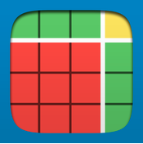 Number Pieces App

Lesson Procedure |  | 21st Century Skills
I do:  Activate Prior Knowledge  - Students need experience with ten frames or base ten blocks. If using ten frames, have one ten frame represent 1 whole and each block of the frame represent one-tenth, or let one 10 rod represent 1 whole and each individual unit represent 1 tenth.  - Tell students base ten blocks can model whole numbers and model fractions. Demonstrate - Ask, ‘How many rods model 5/10? (5). How many rods represent 10/10? (a flat). Manipulate concrete materials. |  | find, validate  remember, understand  communicate
You do:  - Present the information from Math Sense 4, page 198 explaining tenths in fraction and decimal form as well as how to use a place value mat to show a decimal.  - Present the Screencast –Representing Tenths for a more in-depth look.  - Discuss screencast. Review tenths concept by using Pearson interactive tools on the Smartboard – see sample below. |  | collaborate, communicate  analyze, synthesize
We do:  - Ask students to work on page 199, questions 2, 3, 4 and 5. They may collaborate and use any manipulatives available.  - Working in pairs, using iPads, ask students to access and explore the Fractions app by Brainingcamp for further reinforcement of tenths. |  | collaborate, communicate  analyze, synthesize  critical thinking  evaluate, leverage
We share:  - Using base ten blocks, have students take turns demonstrating a model of tenths as a fraction and as a decimal. Have them discuss where the decimal point would go on the place value mat. They can also draw the fraction / decimal on cm grid paper if more practice is required. |  | collaborate, communicate  critical thinking  evaluate, leverage  create, publish  citizenship
Differentiation
Adaptations:  - Any student needing adaptations or support can make a cue card – draw a square to represent 1 whole, and a rod to represent 1 tenth.  - Have students’ practice counting flats by ones and rods by tenths, until they grasp the concept.  - Review the screencast and explore fractions using the app-Fractions by Brainingcamp as often as needed. | Enrichment:  - Students could model tenths using other materials such as Cuisenaire Rods – an orange rod could represent one whole and a white one, 1/10.
Assessment:
Ask students to write a response to this question: Why is the decimal point important? Encourage them to use pictures, numbers and words.
Have them play ‘matching fractions’. Observe students.
Record observations as you rotate around the room, observing students share what they know.

Teacher Reflection:
Discourage reading a decimal as a point. Decimals should be read the same as fractions, ex: 0.4 is ‘zero and 7 tenths’. Letting the students work together allows you to roam, listen and support the students. This further informs the direction of your instructional strategies.

Pearson Interactive Tools –nsvs website

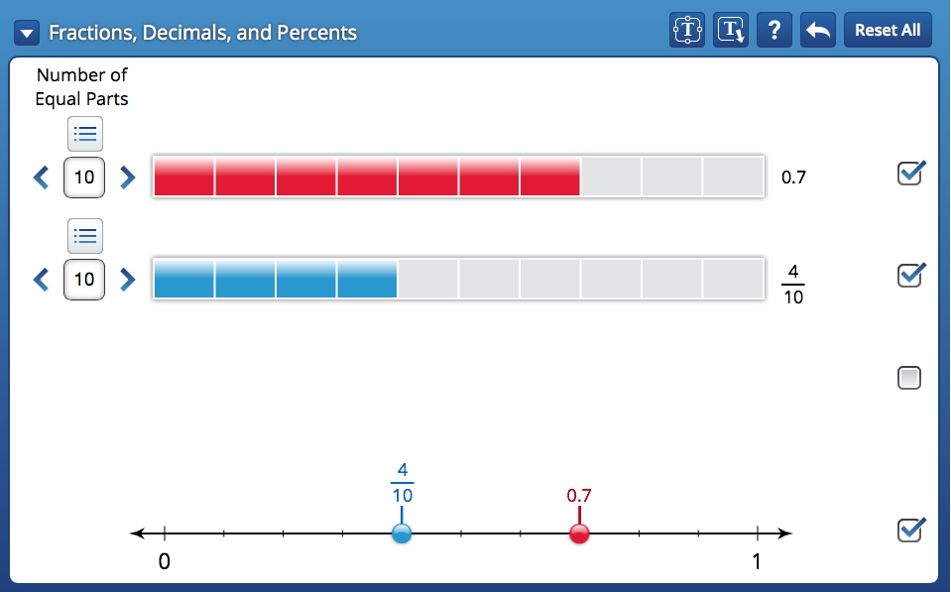

Matching Fractions
Work with a partner.
You will need 15 cards with fractions written on them, a geoboard,
geobands, Pattern Blocks, square dot paper, and triangular dot paper.
- Place the cards face down.
- One student chooses a card and reads the fraction.
- Work together to model the fraction using a geoboard and
geobands, or Pattern Blocks.
- Draw a picture of your model on paper.
If you used a geoboard to model the fraction,
draw it on square dot paper.
If you used Pattern Blocks to model the fraction,
draw it on triangular dot paper.

Take It Further: Write fractions with tenths, such as
, , and on cards.
Put these cards in your pile.
Repeat the activity.

Master 1.20

