Math 4
Subject: Math
Unit: Adding and Subtracting Decimals to Hundredths

Learning Target: Students will learn that money amounts are usually written using decimals, that money amounts can be written using place value, and that money amounts can be added and subtracted using different strategies.

Curriculum Outcomes:
N11.04 Determine the approximate solution of a given problem not requiring an exact answer to hundredths. Students will estimate sums and differences.
N11.05 Count back change for a purchase.
N11.06 Determine an exact solution using mental math strategies. (add and subtract to hundredths using personal strategies)

Screencast Support:
Money

Estimating and Adding Hundredths

Subtracting Decimals Using Base Ten Blocks

Resources/AT Tips:
- iPads : Explain Everything App App Showbie 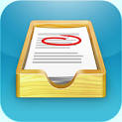
- Math Sense 4 text p. 210, 211
-Decimal place value mat – label it to make it a money place value chart
- Play money
-Adding and Subtracting Activity Sheet (below)
- Pearson interactive money tool (nsvs site) – use to demonstrate
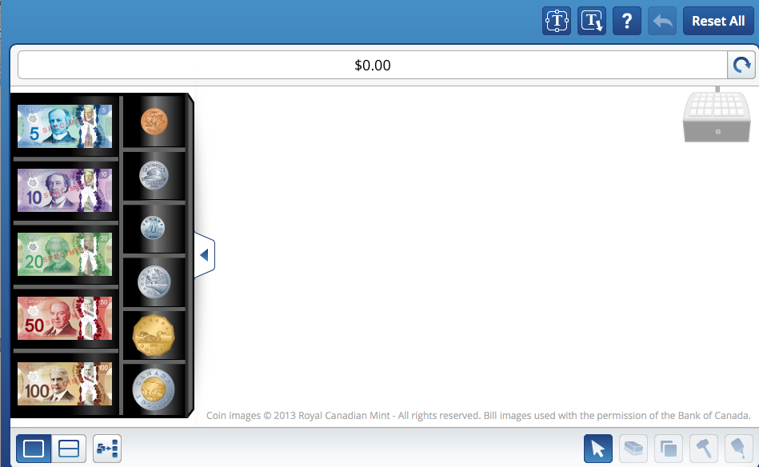

- Money / Place Value chart
Dollars  (Ones) | Dimes  (Tenths) | Pennies  (Hundredths)
2 | 1 | 5

$2.15 - 2 dollars, 15cents

Lesson Procedure |  | 21st Century Skills
I do:  Activate Prior Knowledge  - Review the value of base ten blocks when modeling decimals.  (flat= 1whole , rod= 1 tenth, unit cube = 1 hundredth). Demonstrate using concrete base ten blocks.  Demonstrate using Pearson interactive base ten blocks also. (nsvs site)  - Review how to estimate to the nearest dollar.  - Discuss the fact that money uses base ten with tenths and hundredths.  - Review the value of each coin and bill.  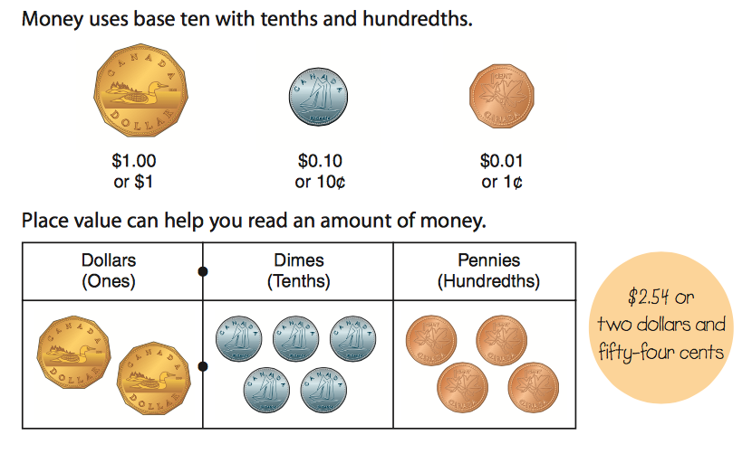 |  | find, validate  remember, understand  communicate
You do:  - Present the following menu on the SmartBoard. Provide students with play money and decimal place value mats. Have them collaborate to find the items they can purchase if they only had $10 dollars to spend.  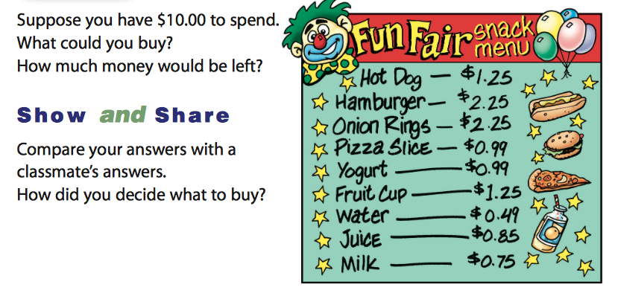 |  | collaborate, communicate  analyze, synthesize
We do:  - Have students share their lists and the exact amounts left over.  - View items in question 5 and 6 on page 214 of the text, Math Makes Sense 4. Have them collaborate together; they use the play money to demonstrate estimation for the cost for purchasing various items. They record their work using the apps, Explain Everything or Showbie.  - Together watch the screencasts.  - For practise, students complete the activity sheet- Adding and Subtraction Decimals. (below)  - Collaboratively, have them practice making change from $5.00. Use decimal / place value/money chart. |  | collaborate, communicate  analyze, synthesize  critical thinking  evaluate, leverage
We share:  - Together correct text and / or activity sheet; have some students use the SmartBoard money tools or the Pearson interactive money tool to model the estimation, addition and subtraction of money. Continue reviewing and practicing addition and subtraction money word problems. |  | collaborate, communicate  critical thinking  evaluate, leverage  create, publish  citizenship
Differentiation
Adaptations:  - Provide students with a visual cue card representing coin and dollar values.  - View the screencast, Money.  - Students can start with money amounts that are dollars and tenths of dollars first. When ready they can add pennies or hundredths of dollars. Use money chart to assist. | Enrichment:  - Get students to make change for $10 using a variety of coins; the greater number of coins that can be used, the least amount of coins, etc.  - Have them play store with a partner, increasing the value of the items to be purchased.
Assessment:
- Ask students to work in pairs. One student will be the shopper; the other will be the store clerk. Provide each pair of students with a newspaper flyer, or a sales flyer you have prepared, and play money. The play money given to the clerk should include both coins and bills. The shopper should be given bills only. The shopper will select an item to purchase from the flyer and will pay the clerk for the item. The store clerk must count back the change from the purchase. Students should switch roles in order to ensure that both students have the opportunity to count back change.
- Record observations as you rotate around the room; noting how the students are doing. Assist as required.

Teacher Reflection:
Make sure students manipulate play money, decimal place value mats and a hundreds chart for ‘counting on’. Have on going discussions about estimating and both addition and subtraction strategies as you work through these activities.

Practice adding and subtracting decimals using play money. Do not rush this portion of the unit. The more ‘hands on’ and visual, the better the comprehension.

Name Date
Adding and Subtracting Decimals to Hundredths
1. Find each sum.
a) $4.76 b) $5.85 c) $2.50 d) $8.59
+ 2.13 + 4.38 + 5.75 + 4.26

2. Find each difference.
a) $8.45 b) $7.63 c) $10.24 d) $6.81
– 6.20 – 2.81 – 5.87 – 2.93

3. What is the change from $10.00 when you spend each amount?
a) $7.22 b) $1.43 c) $2.98 d) $6.37

