Grade 4
Grade: 4 Subject: Math
Unit: Patterns/Relations
Learning Target:
Exploring different ways to represent terms of patterns.

Curriculum Outcomes:
SCO PR01 – Students will be expected to identify and describe patterns found in tables and charts, including a multiplication chart.
PR02 - Students will be expected to translate among different representations of a pattern (a table, a chart, or concrete materials).
PR02.01 Create a table or chart from a given concrete representation of a pattern.
PR02.02 Create a concrete representation of a given pattern displayed in a table or chart.
PR02.03 Translate between pictorial, contextual, and concrete representations of a pattern.
PR02.04 Explain why the same relationship exists between the pattern in a table and its concrete representation.
Resources/AT Tips:
Math Makes Sense 4
Explain Everything

Showbie
Grid paper (below)
Pattern Blocks by math learning center

Lesson Procedure
I do:
- Activate Prior Knowledge - Have students show different ways these decreasing patterns could be extended.

80, 40, …

925, 825, ….

1000, 500, …
- The elements that make up increasing and decreasing patterns are called terms. Each term builds on the previous term.
- Using concrete examples show how patterns can be represented in different way. E.g.

Input Output  1 2  2 6  3 12  4 20  5 30  6 ?  7 ? | Step 1 2 3 4 5 6 ? … 10  No. of dots 2 6 12 20 30 ? ? … ?

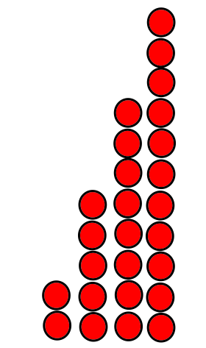
Using this pattern create 2 representations of the pattern and extend it. This should be done as a class.

- Review the connect section on page 11 of Math Makes Sense 4

You do:
- Math Makes Sense 4 page 12 – 1 (students will need guidance setting this question up), 2 allow students to use pattern blocks or the pattern block app on their iPads, 3
- Complete practice sheet (below) and pass in using showbie

We do:
- Students will collaborate to make an explain everything screencast. Students will create a screencast with an extending pattern in multiple representations. Must have two charts and a concrete example. Students use the Showbie app to pass these in.

We share:
- Share and celebrate screencast made by students. Have a few students share their screencast on the smartboard with the class.

Differentiation
Adaptations:  Students use pattern blocks and build growing patterns, plot the pattern in a chart. | Enrichment:  Math Makes Sense page 13 question 4
Assessment:
- Students are continuously assessed for comprehension and application. Support is given when students are struggling with the concept
- Students demonstrate their understanding through using concrete materials and charts.

Notes:

Extending Number Patterns
1. Here is a pattern made with squares.
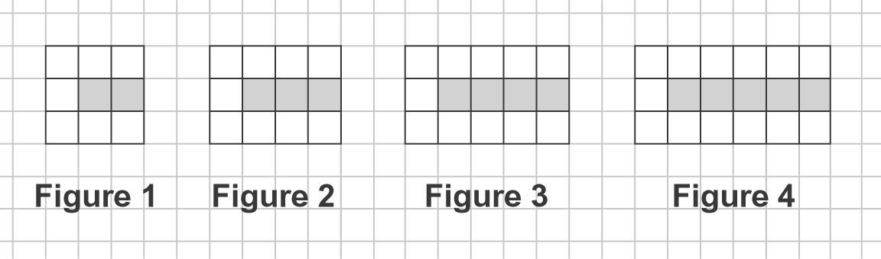

- Complete the table.

Figure | Number of Grey Squares | Number of White Squares
1
2
3
4

- How many white squares will be in the figure with 10 grey squares?

c) How many grey squares will be in the figure with
29 white squares?

1-cm Grid Paper

