Grade 4
Grade: 4 Subject: Math
Unit: Measurement: Time quarter past
Learning Target: Telling Time – Quarter after

Curriculum Outcomes: M01.02 Express the time orally and numerically from a 12-hour analog clock
Screencast support: Telling Time quarter after

Resources/AT Tips: screencast, Analog Clock Whiteboard clock, Team Shake app, Rock the clock and tick-tock create a clock sheet TPT

Lesson Procedure |  | 21st Century Skills
I do: These lessons depend on scaffolding. Understanding time to the hour, time to the half hour before understanding time quarter after is important.  Activate prior knowledge and review last lesson. – 60 seconds in a minute, 60 minutes in an hour.  Access interactive whiteboard clock. Point to the hour hand and the minute hand, practice telling time to the hour and to the half hour with a few examples.  On whiteboard clock draw a line down the center of the clock. The clock can be split in half. Half of 60 minutes is 30. It takes the minute hand 30 minutes to travel half way around the clock. Draw a second line across the middle (9-3). Now the clock is divided in quarters. Each quarter is 15 minutes. It takes 15 minutes for the minute hand to travel from the 12 to the 3. Each quarter is 15 minutes. Make the relation between four quarters (15 minutes) making 60 minutes. Show 12:15 on the interactive clock. We say it is 12:15 or quarter after 12. Point their attention at the minute hand and the hour hand. The hour is just slightly past the hour and the minute hand is on the three. It is 15 minutes past 12 or quarter after.  Do a few more examples taking the time to use the proper vocabulary and modeling both ways to say the time and showing the digital time on the board.  Show Screencast – Telling time quarter after |  | find, validate  remember, understand  collaborate, communicate  analyze, synthesize  critical thinking  evaluate, leverage  create, publish  citizenship
We do:
Do a variety of examples. Using the team shake app have students come up and set the time. Pay close attention to the minute hand and the hour hand. Students tell the time using the vocabulary quarter after. When students tell the time write it, as it would be seen on the board, i.e. 8:15 and emphasize placement of the hour hand just past the hour, it is no longer exactly on the hour. They will need a lot of practice telling the time and using the vocabulary.

You do: Have students access clock for kids app on their iPads. Go to practice – Quarter after – Play “The Time Is?”
Work on tick-tock create a clock and rock the clock sheet TPT, circulate while students are doing this correcting as you go checking for comprehension.

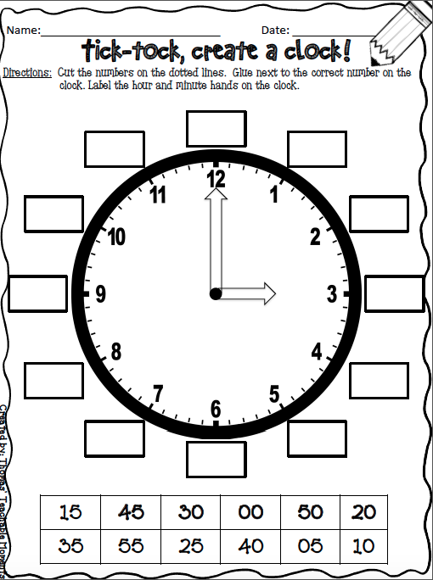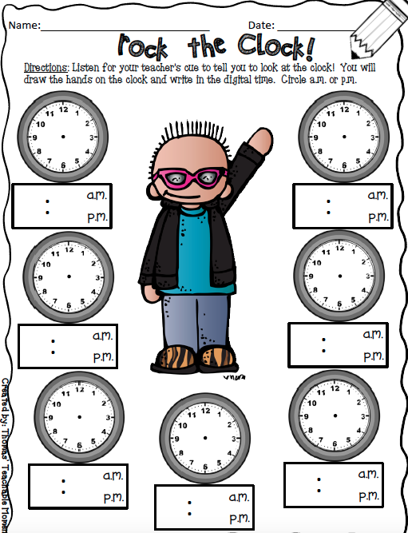

We share:
Come back together as a group. Show 5 different times one at a time on the interactive whiteboard. Give students 5 seconds and then have the whole class answer at the same time. Make sure each time is at quarter past and students are using the vocabulary of quarter past and exact time i.e. eight fifteen, quarter past eight

Differentiation
Adaptations:  Have struggling students watch the screencast Telling Time: to the half hour.  Give one on one attention to struggling students. Have them us manipulative clock and practice making time to the hour and describing that time. | Enrichment:  Students that have a strong grasp of this can move onto the next lesson in the series and begin by watching the screencast on Telling Time: quarter to.
Evaluation:

Continuously assess students. Take anecdotal notes of students, watching for struggling students. This unit is heavy on scaffolding students need to understand each before they move on.

