Grade 4
Grade: 4 Subject: Math
Unit: Measurement: Telling Time to the minute

Learning Target: Telling Time to the minute

Curriculum Outcomes: M01.02 Express the time orally and numerically from a 12-hour analog clock
Screencast support: Telling Time to the minute

Resources/AT Tips: Screencast, Analog whiteboard clock, Team Shake app, set of premade clock cards with time between the 5minute marks and matching times in digital notation for every two students, True or False & Juggling Time TPT, mini assessment.
,
Lesson Procedure |  | 21st Century Skills
I do:  - These lessons depend on scaffolding. Understanding time to the hour, time to the half hour, telling time quarter past, and telling time quarter to before understanding time quarter after is important.  - Activate/validate prior knowledge and review last lesson. – 60 seconds in a minute, 60 minutes in an hour.  - Access interactive whiteboard clock. Point to the hour hand and the minute hand, practice telling time to the hour, the half hour, quarter past and quarter to with a few examples. Make sure the students remember and understand these times.  - Ask students when is a time that they need to know the exact time? Allow for students to communicate answers  - Explain that each number on the clock is 5 minutes apart, we can count by fives and then use or counting on strategies to tell time to the minute. Show examples using Analog whiteboard clock.  - Show screencast  - Review how we say time, i.e 7:21 is 21 minutes after 7 or 11:54 is 54 minutes after 11 or 6 minutes to 12.  - Take time throughout the day to point out and ask the time. |  | find, validate  remember, understand  collaborate, communicate  analyze, synthesize  critical thinking  evaluate, leverage  create, publish  citizenship
We do:
- Students collaborate and communicate using the matching time game in groups of two. Mix up the cards and place them face down. Students take turns turning over 2 cards. If the cards match keep them. If they do not match put them back face down. Keep playing until all cards are done. If all sets are different groups that finish quickly can switch cards and play again.
- Students may work in groups to analyze clocks in True or False and determine whether the stated time is correct.
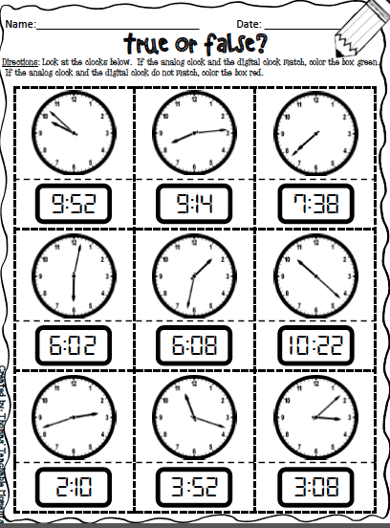
When groups are completed they may begin Juggling Time to support telling time to the minute.
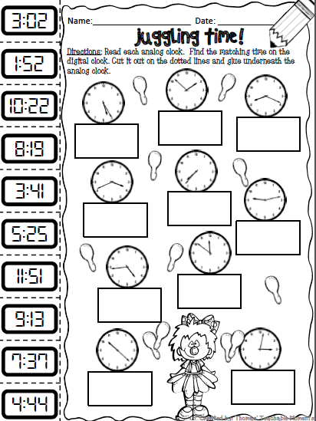

You do:
- Students are to complete mini assessment on their own. This is to support ongoing assessment of students.

We share:
- Come back together as a group. Show 5 different times one at a time on the interactive whiteboard. Give students 5 seconds and then have the whole class answer at the same time. Make sure each time correct vocabulary is being used.
- Students attention should be brought to the class clock throughout the day and the question asked “What time is it?” not just in math class.

Differentiation
Adaptations:  Have struggling students watch the screencast Telling Time to the minute.  Give one on one attention to struggling students. Have them us manipulative clock and practice making time to the hour and describing that time. | Enrichment:  Students that have a strong grasp of this can move onto the next in the series and begin by watching the screencast on Analog vs Digital
Evaluation:

- Students are to complete mini assessment on their own. This is to support ongoing assessment of students. Student assessment should be ongoing on and asked to apply knowledge throughout the day be telling time in the moment.

Notes:

Blank Analog Clocks
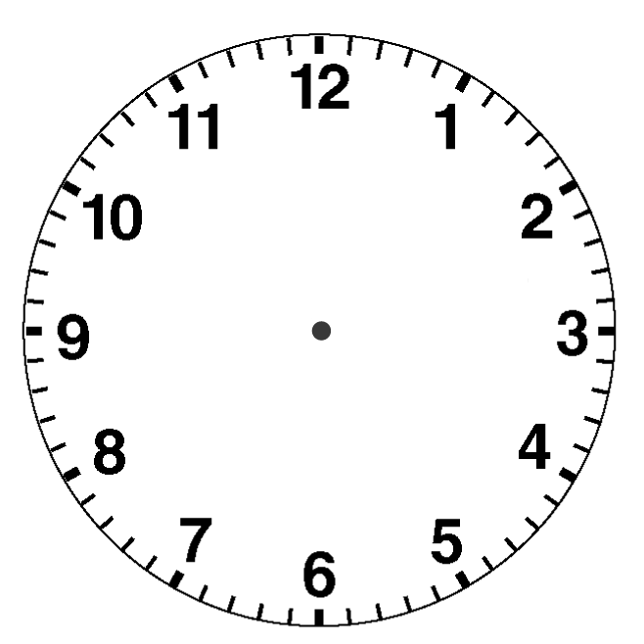

Matching Cards for digital notation

Telling Time to the Minute

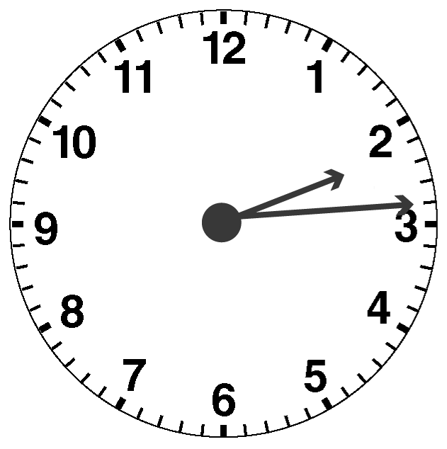
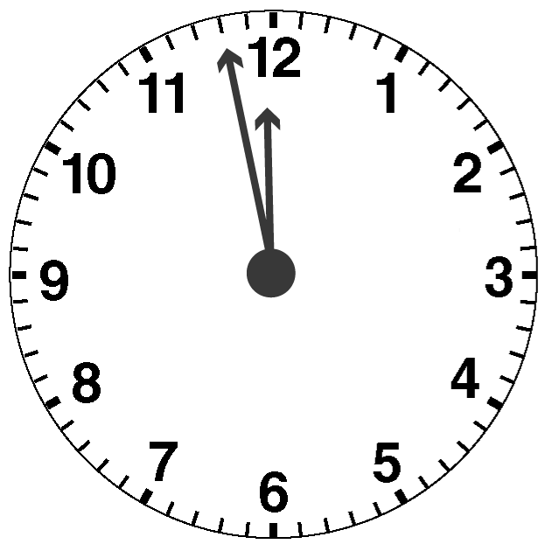
1. Write each time two ways.
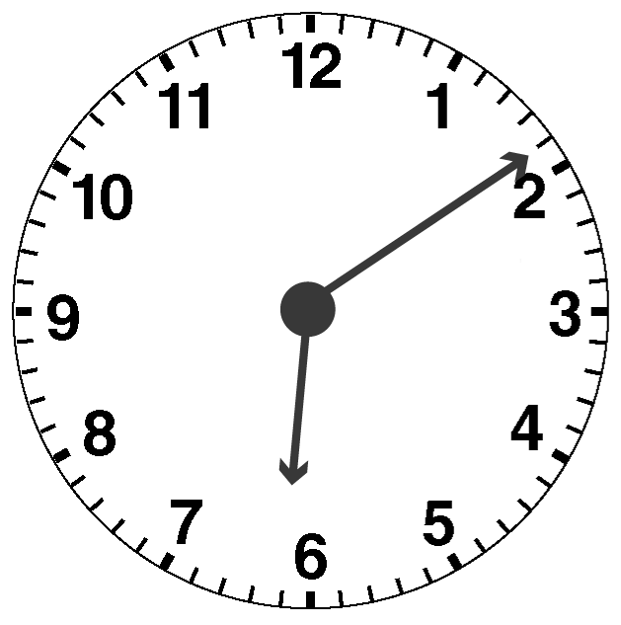
a) b) c)

2. Draw an analog clock to show each time.

a) quarter to 4 b) 21 minutes after 8

c) 9 minutes to 1 d) 25 minutes before 4

