Grade 4
Grade: 4 Subject: Math
Unit: Measurement Time half hour
Learning Target: Telling Time to the hour – to the half hour

Curriculum Outcomes: M01.02 Express the time orally and numerically from a 12-hour analog clock
Screencast Support: Telling Time to the half hour

Resources/AT Tips: Interactive Analog Whiteboard clock
Telling Time by the hour and half hour sheet TPT
True or False sheet TPT (hour, half hour)
iPads
Kids Clock app
Teamshake app
Lesson Procedure |  | 21st Century Skills
I do:  These lessons depend on scaffolding. Understanding time to the hour before understanding time to the half is important - See lesson on time to the hour. Activate prior knowledge and review last lesson. – 60 seconds in a minute, 60 minutes in an hour.  Access interactive whiteboard clock. Point to the hour hand and the minute hand, practice telling time to the hour with a few examples.  On whiteboard clock draw a line down the center of the clock. The clock can be split in half. Half of 60 minutes is 30. It takes the minute hand 30 minutes to travel half way around the clock. We say it is half past the hour (eight) or eight thirty, we write 8:30. Pay close attention to the minute hand on the 6 (30 minute mark) and the hour hand is between two hours – this needs to be explicitly pointed out.  Show Screencast – Telling time to the half hour |  | find, validate  remember, understand  collaborate, communicate  analyze, synthesize  critical thinking  evaluate, leverage  create, publish  citizenship
We do:
Do a variety of examples. Using the team shake app have students come up and set the time. Pay close attention to the minute hand and the hour hand. Students tell the time using the vocabulary half past. When students tell the time write it, as it would be seen on the board, i.e. 8:30 and emphasize placement of the hour hand between the two numbers, it is no longer exactly on the hour.

You do: Have students access clock for kids app on their iPads. Go to practice – Half Hour – Play “The Time Is?”

With your tablemate continue to practice telling time to the half hour. One student will put a time to the half hour on the iPad and the other student will tell the time to the half hour. As you circulate watching, listening and helping listen for the specific vocabulary of half past.

Work on Telling Time by the hour and half hour sheet and True or False (hour/half hour) TPT , circulate while students are doing this correcting as you go checking for comprehension.

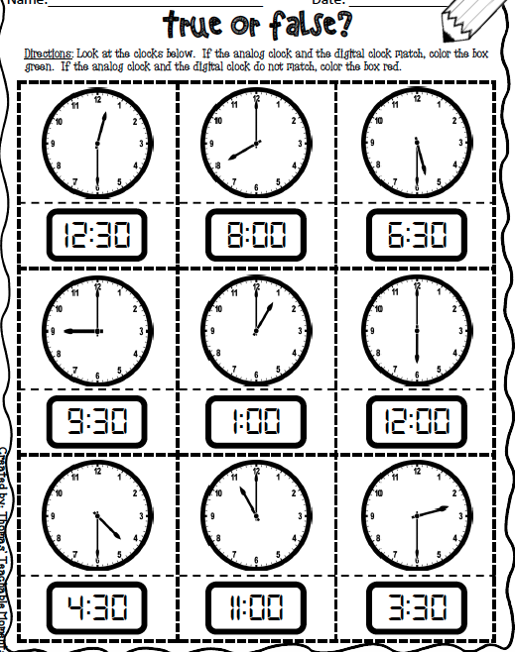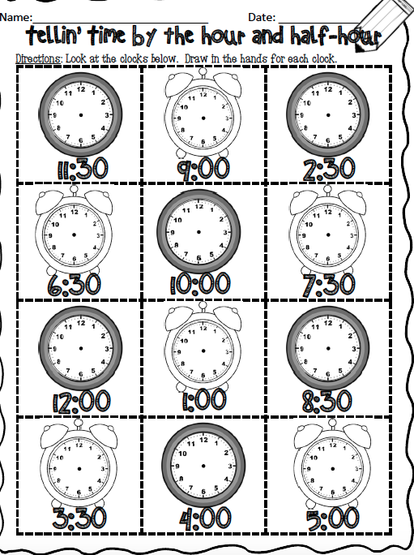

We share:
Come back together as a group. Show 5 different times one at a time on the interactive whiteboard. Give students 5 seconds and then have the whole class answer at the same time. Make sure each time is at the thirty and students are using the vocabulary of half past.

Differentiation
Adaptations:  Have struggling students watch the screencast Telling Time: to the half hour.  Give one on one attention to struggling students. Have them us manipulative clock and practice making time to the hour and describing that time. | Enrichment:  Students that have a strong grasp of this can move onto the next lesson in the series and begin by watching the screencast on Telling Time: quarter past.
Evaluation:

Continuously assess students. Take anecdotal notes of students, watching for struggling students. This unit is heavy on scaffolding students need to understand each before they move on.

Notes:

